Halsall/HSLF1000 NAME...............................
Paul Halsall.

Geography Assignment

Modern history requires some knowledge of European geography. For this assignment atlases are available in the Reference Room of the Library. Other geographical information can be gathered from the Encyclopaedia Britannica or Encyclopedia Americana which open each article on a country with an account of its geography.

1. Mark these cities on Map I below with a dot (write the city's name next to the dot). These will all come up during the course. Next to the name of each city indicate in which present day (Feb. 1994) country it is situated.

1. Paris ________ 2. Rome _________ 3. London _________
4. Bonn ________ 5. Moscow _________ 6. Manchester ________
7. Milan ________ 8. Vienna ________ 9. Belgrade ________
10. Berlin _______ 11. Madrid ________ 12. Athens ________
13. Munich ________ 14. Prague ________ 15. Brussels ________
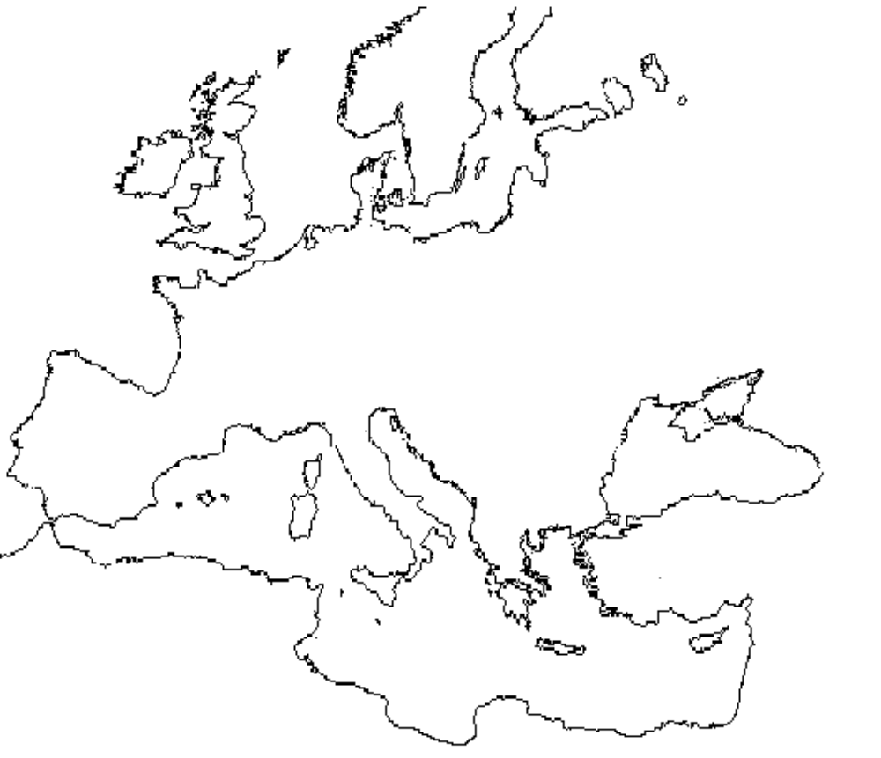
2. Mark on Map II below the locations of the following mountain ranges, rivers, seas, and islands. For Mountains use this symbol, for rivers use a line, and with the islands write the name of the island next to it.

Mountain Ranges:
1. The Alps 2. The Pyrennees 3. The Carpathians
Rivers:
4. The Rhine 5. The Danube 6. The Elbe
7. The Oder
Islands:
8. Sicily 9. Ireland 10. Corsica
11. Great Britain 12. Sardinia 13. Cyprus
14. Crete 15. Malta
Seas
16. Black Sea 17. North Sea 18. Mediterranean Sea
19. Baltic Sea 20. Atlantic Ocean

3. Many modern European states did not exist until 1914, some not until 1992. For instance, `Italy' was not a united country until 1871. These terms were used, however, although somewhat vaguely. On this final map then indicate the approximate areas meant by the following names.

1. France 2. Germany 3. Italy
4. Spain 5. England 6. Russia
7. Greece 8. Poland 9. Croatia
10. Sweden

4. What is the number of people speaking the following languages, and in which modern countries do they live? (You can get this information from the World Almanac or similar publications, available in the Library Reference Room. (If any word below does not appear in the reference book you use, look it up in a dictionary.)

Language Number of Speakers Modern Countries
Italian 60 Million Italy, USA, Switzer-
(example) land, Argentina.

French

Spanish

Portuguese

Russian

Ukrainian

Croatian

Magyar

German

Dutch

English

Hindi

Mandarin

Make a note here of three odd facts/observations you picked up in your research on these languages. Also be prepared to discuss in class what your results mean.

1.

2.

3.

